Lab 9 Logistic and Count-Variable Regression
Remington S. Bland

For the logistic regression:
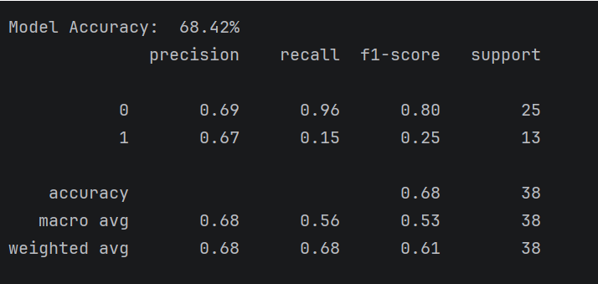
The model’s accuracy is 68.42 percent. The lowest precision value is 0.67 in class 1. None of the categories have at least 30 support. I did not obtain a pseudo-R^2 value since the model is limited in capabilities.
For the count-variable regression:
- Your model should include 4 significant predictors. What are they?
- Which of these predictors is the most significant (hint: look at the 'coef' column)
- Do any of your significant predictors have an overinflated VIF (VIF > 10)?
- How much of the variability is captured by the model (hint: look at pseudo-r^2)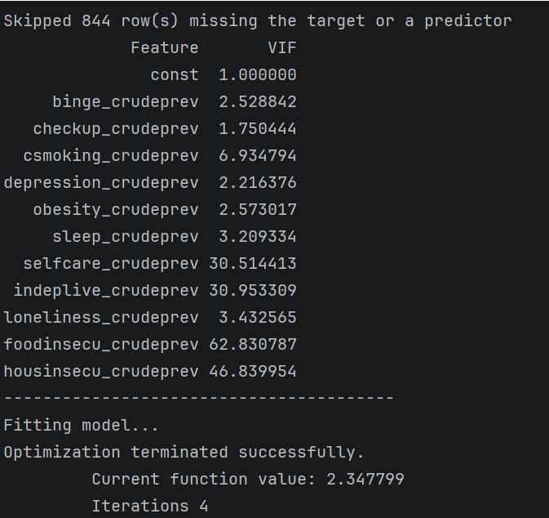
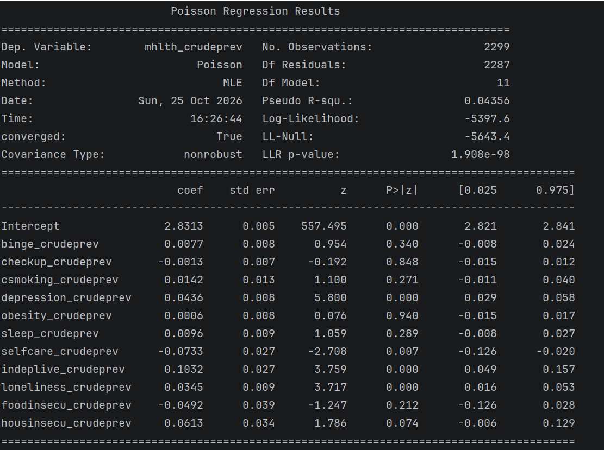

There are 4 significant predictors: depression_crudeprev, selfcare_crudeprev, indeplive_crudeprev, and loneliness_crudeprev. The most significant predictor is indeplive_crudeprev which has a coefficient of 0.1032. Two of the significant predictors have VIF’s greater than 10, and they are selfcare_crudeprev (30.51) and indeplive_crudeprev (30.95). The pseudo R^2 value tells how much variability is captured by the model, and about 4.36 percent is captured.

